**First Presentation of Project on**

**“SMART WHEELCHAIR FOR PARALYZED”**

***Presented by***

**KNR18EE024. JASIRA T P**

**KNR18EE034. NAYANA RAMESHAN**

**KNR18EE046. SHRAVAN SREEDEEP**

**KNR18EE048. SOORYA P**

***under the guidance of***

**Dr. C SREEKUMAR**



**DEPARTMENT OF ELECTRICAL & ELECTRONICS ENGINEERING**

**GOVT. COLLEGE OF ENGINEERING KANNUR- 670563**

**Oct 2021**

**ABSTRACT**

Paralyzed stroke patients are unable to normally communicate with their environment. For these patients, the only part of their body that is under their control, in terms of muscular movement, is their eyeballs.

The biggest problem that paralyzed patients face is leading their own life without others support. This include basic day to day operations like switching on basic devices like fan, bulb etc.

An automated working prototype of a smart wheel chair working with a home automation system that can be controlled by eye tracking is implemented in this work. The prototype is designed for the paralysed people with only motor functions for eye movement. This method takes care of surrounding obstructions and decisions are taken accordingly.

**OBJECTIVES**

* To track eye movement and control basic devices like bulb, fan etc.
* To design and implement an autonomous electric wheelchair.
* To control the electric wheel chair by tracking eye movements.

**LITERATURE REVIEW**

[1] Joseph K George, Subhin K B, Arun Jose,Hima T, “Eye Controlled Home-Automation For Disables”, IOSR, 2019

A low cost eye movement based detection device for controlling home appliances has been discussed in this paper. The device is based on the acquisition of eye blinks which is comparatively inexpensive, efficient in terms of linear relationship of the signal over the eye movements that makes it suitable for the application. The device here incorporates activation and deactivation of appliances such as fan, bulb, GSM and alarm etc. The method of eye tracking using camera requires a fully dedicated system with image processing software during the entire working of the unit.

[2] Tan Kian Hou, Yagasena and Chelladurai, “Arduino based voice controlled wheelchair”, ICE4CT, 2019

This paper describes the design of a smart, motorized, voice controlled wheelchair using embedded system. Proposed design supports voice activation system for physically differently abled persons incorporating manual operation. This paper represents the “Voice-controlled Wheel chair” for the physically differently abled person where the voice command controls the movements of the wheelchair. The voice command is given through a cellular device having Bluetooth and the command is transferred and converted to string by the BT Voice Control for Arduino and is transferred to the Bluetooth Module SR-04connected to the Arduino board for the control of the Wheelchair.

**SMART WHEEL CHAIR**

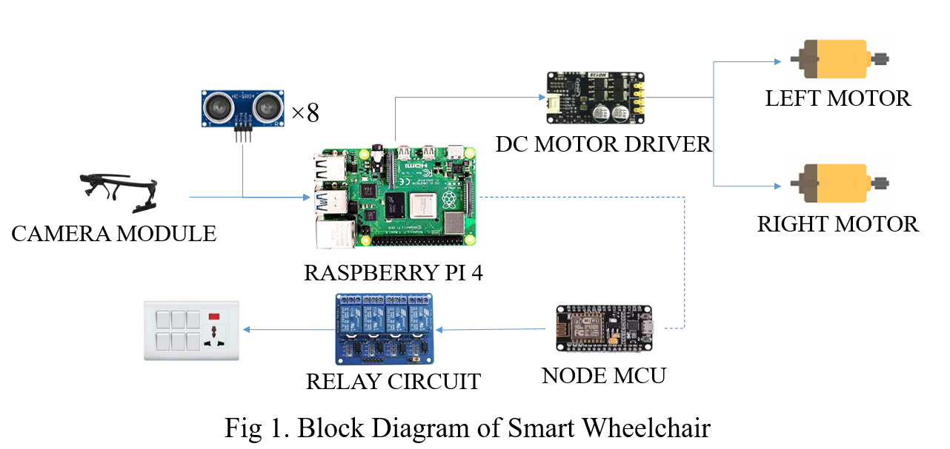

The camera module in eye tracker captures the eyeball movement. A python program for eye tracker identifies the position of the pupil. The combination of position of the pupil is transmitted to the micro controller with the help of Bluetooth module. The micro controller determines the command that needed to be executed according to the position of pupil. Based on the command wheelchair or home appliances are selected. If the selected mode is wheel chair, then the movement is controlled based on the position of pupil. Else if home appliances are selected, the devices are turned ON based on the combinations of the pupil with the help of Node MCU and relay circuits.

**STATUS OF PROJECT**

Eye tracking program is developed and its results are shown below.

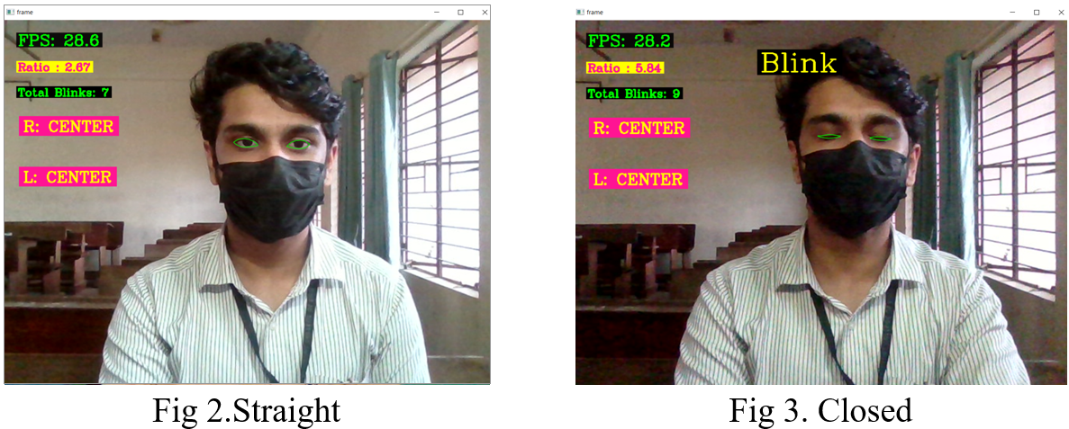

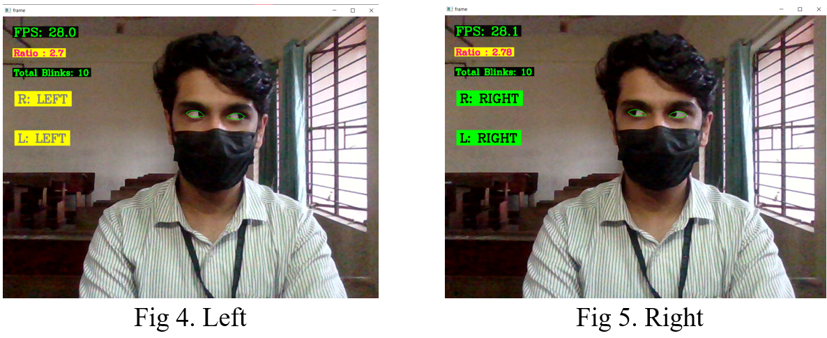

**WORK PLAN**

|  |  |  |  |  |  |  |  |  |  |  |
| --- | --- | --- | --- | --- | --- | --- | --- | --- | --- | --- |
| **Work** | Oct 2021 | Nov 2021 | 1-2 week Dec 2021 | 3-4 weeks Dec 2021 | 1-2 weeks Jan 2022 | 3-5 weeks Jan 2022 | Feb  2022 | Mar  2022 | April 2022 | May 2022 |
| Topic selection and preliminary works |  |  |  |  |  |  |  |  |  |  |
| Literature Survey |  |  |  |  |  |  |  |  |  |  |
| Program and train machine learning model for eye tracking. |  |  |  |  |  |  |  |  |  |  |
| Design and implementation of mini prototype of autonomous wheelchair. |  |  |  |  |  |  |  |  |  |  |
| Design and implementation of the circuit for home automation. |  |  |  |  |  |  |  |  |  |  |
| Interface the eye tracker, home automation and wheelchair together. |  |  |  |  |  |  |  |  |  |  |
| Fabrication of home automation system. |  |  |  |  |  |  |  |  |  |  |
| Hardware implementation of eye tracking glasses. |  |  |  |  |  |  |  |  |  |  |
| Hardware implementation of autonomous wheel chair. |  |  |  |  |  |  |  |  |  |  |
| Test and solve real time issues. |  |  |  |  |  |  |  |  |  |  |

**CONCLUSION**

Paralyzed stroke patients are unable to normally communicate with their environment. The biggest problem that paralyzed patients face is leading their own life without others support. As a solution to this problem, a smart wheel chair working with a home automation system that can be controlled by eye tracking is implemented in this work. The literature review for the proposed model are going on. For the base controller Raspberry Pi 4 have been selected. The eye tracking model is developed in python language using opencv and mediapipe libraries.

**REFERENCE**

1. Ahmad F. Klaib1, Nawaf O. Alsrehin1, Wasen Y. Melhem2, Haneen O. Bashtawi2, Aws A. Magableh1. “Eye Tracking Algorithms, Techniques, Tools, and Applications with an Emphasis on Machine Learning and Internet of Things Technologies”, September 2020
2. Mohammed Saifuddin Munna1, Juliana Shetara, Shantanu Bhattacharjee3, Md. Zahed Hossain Bhuiyan4, “Design & Implementation of a Mind Controlled Home Automation System”, January 2017
3. Pramodini A. Punde, Dr. Mukti E. Jadhav, Dr. Ramesh R. Manza, “A study of Eye Tracking Technology and its applications”, 2017 IEEE
4. Tan Kian Hou, Yagasena and Chelladurai“Arduino based voice controlled wheelchair”, 2020
5. Mohammed Hayyan Al Sibai, Sulastri Abdhul Manap, “A Study on Smart Wheelchair Systems”, Dec 2015 Research Gate
6. Deepak Kumar, Reetu Malhotra, S R Sharma, “Design & Construction of a Smart Wheelchair”, 2019 Science Direct
7. Georges Boustany, Alaa El Deen Itani, Rayan Youssef, Omar Chami, Ziad O. Abu-Faraj, “Design and Development of Rehabilitive Eye-Tracking Based Home Automation System”, 2016 IEEE
8. Joseph K George, Subin K B, Arun Jose, Hima T, “Eye Controlled Home-Automation For Disables”, 2017 IOSR-JEEE
9. Deepak Kumar Lodhi, Prakshi Vats, Addala Varun1, Prashant Solanki, Ritakshi Gupta1, Manoj Kumar Pandey, Rajat Butola, “Smart Electronic Wheelchair Using Arduino and Bluetooth Module”, May 2016 IJCSMC